Faust’s House
In Prague, in our capital city, there is a baroque house and legend says in this house lived Doctor Faust. He sucked his soul to the devil and the devil took him to hell. Everybody said Faust’s house was haunted. After that the poor student went to Faust’s house because he didn’t have money to sleep in the inn. Every day “a ghost” gives him money for something to eat. He read a book after Faust, and he found out about magic power. He also wanted more money and magic power. One day he spend all the money which he lend and he came back to Faust’s house, and nobody saw him after that. Other people went to the house to check it and they saw a hole on the ceiling. The legend says the devil took the student to hell because he wanted more. No Faust didn’t live in this house. In this house lived the alchemist, Edward Kelly. He worked for Rudolph the second. Kelly wanted to make a potion of never-ending life, philosopher’s stone and more.

Faust’s house
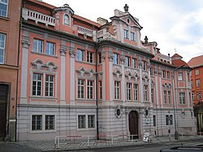 Edward Kelly
