Legend About Radegast
Long time ago ruled prince Radoch I .
He built a temple for god Radegast .
He has got two sons- Radoch II. and Bludoch . Older brother was successor of prince and smaller brother was Priest in Temple.
Radoch married a woman but god Radegast loved this woman too. Her name was Kněhyně . Radoch II. Every year went to conquer new territory . once Radoch II. went to battle with his sons but his sons died in the battle field . When Radoch came to home his wife was sad because her sons died .
She was angry because her husband was happy his sons died . His wife left him . She came to Radegast and she had a wish.
Her wish was fulfil. Kněhyně and her daughters was Transformed to river. People think that god Radegast live in mountain Radhošt.
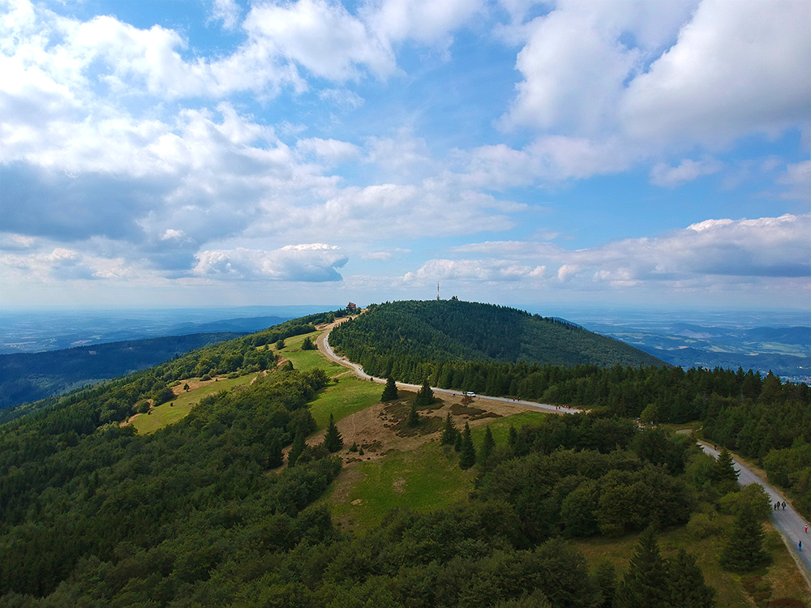
Mountain Radhošť

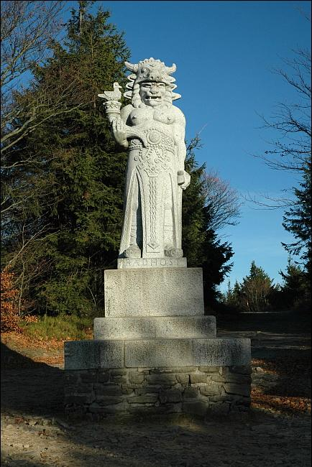
Statue of god Radegast on mountain Radhošť
This legend came from Beskyd mountains .

