

Nature-based Solutions learning scenario

Title
Carbon storage on the Blue lake

Author(s)
Marijana Vuković
Antonija Pavelić

Abstract
Blue Lake is part of the UNESCO global GEOPARK Biokovo - Imotska jezera, and first-grade high school students will explore its role in mitigating climate change. The processes of carbon absorption and storage in the forests of Blue Lake are crucial in reducing CO2 emissions in the atmosphere. Investigating these processes can contribute to understanding how forest ecosystems help regulate the global carbon cycle.
This project aims to raise ecological awareness among high school students through educational workshops and practical research. Students will measure how much carbon dioxide trees at Blue Lake absorb, which is one of the greenhouse gases affecting climate change. They will also calculate their carbon footprint and connect how their lifestyle choices impact carbon dioxide emissions, as well as determine how many trees they need to offset their CO2 emissions. The project is expected to result in a better understanding of the role of Blue Lake in carbon storage and inspire young people towards more sustainable behavior.

Keywords
Sustainable development goals, determination of plants, CO2 emission, carbon footprint, carbon traps

Introduction (leave this section as it is)
“Nature-based solutions (NBS) are solutions that are inspired and supported by nature, which are cost-effective, simultaneously provide environmental, social and economic benefits and help build resilience. Such solutions bring more, and more diverse, nature and natural features and processes into cities, landscapes and seascapes, through locally adapted, resource-efficient and systemic interventions. Nature-based solutions must therefore benefit biodiversity and support the delivery of a range of ecosystem services.”
Source: https://research-and-innovation.ec.europa.eu/research-area/environment/nature-based-solutions_en

To use this Learning Scenario more effectively, teachers are encouraged to:
- Check out the list of recent EU publications on nature-based solutions.
- Explore the various publications and outputs of the NBS EduWORLD project.
- Learn about the European Union’s European Framework for Sustainability Competences GreenComp and how it could help students develop other skills (also available in digital version).
- Consider exploring the “Sustainability Conversations: the GreenComp game”, a conversational game during which players discuss and assess their priorities to build a sustainable future.
- Watch the “Turn your love for nature into a planet-saving career” and the “What is NBS education” videos by NBS EduWORLD, to explore more information about NBS and their connection to education.
- Search for inspiration in the Learning Scenarios developed during the Integrating Nature-Based Solutions in Education (funded by the EC and coordinated by PPMI, in collaboration with EUN) as well as those created as part of the NBS EduWORLD project.
- Read about Nature-based solutions: Transforming cities, enhancing well-being (also available as a detailed PDF).
- Learn more about nature-based solutions by looking at NBS case studies in repositories, such as NetworkNature, Oppla and Urban Nature Atlas.
- Contact local NBS practitioners or scientists working in their area (they can be found through Oppla).
- Use the “Ask Oppla” and NetworkNature Helpdesk service to request help in case of any technical/scientific question on NBS.
- Read the European Union’s European Green Deal to understand the current EU strategy on climate change and COVID recovery.
- Read the European Union’s Biodiversity Strategy 2030 to learn about the challenges Nature faces in Europe.

Overview
Summary
Subject | List all subjects that this learning scenario is intended for. If this is an interdisciplinary lesson, list multiple subjects.  Biology and chemistry
Topic | Indicate below which of the twelve NBS societal challenges your learning scenario addresses:  ☐ Air quality  ☒ Biodiversity enhancement  ☒ Climate resilience  ☐ Green space management  ☒ Health and well-being  ☐ Knowledge building for sustainable urban transformation  ☐ Land regeneration  ☐ Natural and climate hazards  ☐ New economic opportunities and green jobs  ☐ Participatory planning and governance  ☐ Social justice and social cohesion  ☐ Water management
GreenComp Competences | Indicate below which of the 12 GreenComp competences your learning scenario addresses (for more information, refer to pages 12-15 here):  Area: Embodying sustainability values  ☐ Valuing sustainability  ☐ Supporting fairness  ☒ Promoting nature  Area: Embracing complexity in sustainability  ☒ Systems thinking  ☒ Critical thinking  ☒ Problem framing  Area: Envisioning sustainable futures  ☐ Futures literacy  ☐ Adaptability  ☐ Exploratory thinking  Area: Envisioning sustainable futures  ☐ Political agency  ☐ Collective agency  ☐ Individual agency
Age of students | 14 – 18 age
Preparation time | 5 h
Teaching time | 3 x 45 min
Online teaching material(s) used | List here all links to online tools, applications and support documents that you will use during the lesson, such as Padlet, Kahoot, Canva, etc. Make sure the links work. Follow these examples below, showing how to list the online teaching materials:  https://www.tricider.com/brainstorming/2fx2e7PiOUV  https://gp-biokovoimotski.com/sto-su-geoparkovi-unesco-a/  https://plantnet.org/
Offline teaching material(s) used | List here all offline tools, such as paper, glue, etc.  pencil, calculator, measuring tape 20-50 m, worksheets
NBS resource(s) used | List here links to all NBS resources used for this learning scenario. Check the links to make sure they work and can be accessed by everyone.  European Green Deal: https://ec.europa.eu/stories/european-green-deal/#wtEtransModal  Biodiversity strategy for 20230.: https://youtu.be/BsooH3ohiZY  Oppla case founder: https://oppla.eu/case-study-finder

License
Attribution-ShareAlike 4.0 International (CC BY-SA 4.0) This license lets others remix, tweak, and build upon your work even for commercial purposes, as long as they credit you and license their new creations under identical terms. This is the license used by Wikipedia and is recommended for materials that would benefit from incorporating content from Wikipedia and similarly licensed projects.

Integration into the curriculum
The theme of the scenario is integrated into the National Curriculum in Biology for the first grade of the high school program as one of the themes of Sustainable Development.

Aim of the lesson
The goal is to make students aware of how their lifestyle (choosing food, clothing, transportation, consumption of water resources and resources of non-renewable energy sources) affects carbon dioxide emissions and climate change. Also encourage critical thinking about the importance of forests and geoparks not only for the local population but also on a global level.

Outcome of the lesson
Outcomes:
- analyzes the maintenance of a balanced state in nature by connecting one's own behavior and responsibility with sustainable development
- explains the binding and conversion of energy in the processes of substance circulation in the biosphere and connects them with living conditions and the maintenance of life

Trends
List the relevant trends that the lesson incorporates: http://www.allourideas.org/trendiez/results
Student-Centred Learning: students and their needs are at the centre of the learning process.
Learning materials: shift from textbooks to web resources and open source books.
STEM Learning: increased focus on Science, Technology, Engineering, Mathematics subjects in the curriculum.
Project-Based Learning: students receive fact-based tasks, problems to solve and they work in groups.
Collaborative Learning: a strong focus on group work.
Assessment: the focus of assessments is shifting from "what you know" to "what you can do."

21st century skills
Add here how the learning scenario corresponds to 21st century skills. To find out more: P21_Framework_Brief.pdf

Information literacy - using an interactive map and finding sustainable classroom goals.
Cooperation - working in groups, creating a table with carbon footprint traps.
ICT (information, communication and technological) literacy – calculation of a needle print, making a key for determination of trees using leaves.
Communication - conversations with other students.
Critical thinking and problem solving – searching for solutions to problems.
Flexibility and adaptation - finding solutions that can be adapted to the school, for example with a small budget.
Creativity and innovation - creation of digital content for the report

STEM Strategy Criteria
In this Learning Scenario, the following STEM elements and criteria are addressed (provide details for all that apply).To know more about the STEM Strategy Criteria, see here.
Elements and criteria | How is this criterion addressed in the learning scenario
Instruction
Personalization of learning | This lesson is intended to address the different learning needs and interest of students.
Problem and project-based learning (PBL) | Students learn about the subject by solving open-ended questions/problems both individually and collaboratively, with no solution provided by the teacher.
Inquiry-Based Science Education (IBSE) | Students learn in a process in which different questions/problems are presented to them, including investigation and research projects
Curriculum implementation
Emphasis on STEM topics and competencies | The curriculum emphasises STEM key competences and STEM subjects.
Interdisciplinary instruction | In this Learning Scenario, we will examine and implement a variety of activities in a wide spectrum of subjects, biology and chemistry (STEM).
Contextualization of STEM teaching | Lessons are connected to real-world experiences.
Assessment
Continuous assessment | A formative evaluation is carried out, allowing a continuous improvement on the students’ progress
Personalized assessment | The pace of learning and instructional approach are optimised for the needs of each student.
Professionalization of staff
Highly qualified professionals
Existence of supporting (pedagogical) staff | The teaching staff of our school supports activities to make learning and teaching sustainable.
Professional development | Our school provides avenues for the professional development of all staff, and especially on teacher capacity building.
School leadership and culture
School leadership | In our school, there is a school board (manages the school) and teachers', parents' and students' councils that work closely together.
High level of cooperation among staff | Staff are encouraged to support each other and work together and are given the space and time to do so
Inclusive culture | We respect our colleagues’ ideas; we share success and value each other’s unique qualities.
Connections
With industry
With parents/guardians | Students will receive information for calculating the carbon footprint from their parents.
With other schools and/or educational platforms | The activities in outdoor experiences could be shared with other neighbouring schools.
With universities and/or research centers | An expert in sustainability will be invited for the radio programme.
With local communities | We will connect with local Family Farms and learn about sustainability
School infrastructure
Access to technology and equipment | The school is equipped with internet access, as well as laptops and one projector per classroom.
High quality instruction classroom materials | The school provides high-quality instruction materials and staff are encouraged to create personalised resources for students.

Activities
Describe here in detail all activities during the lesson and the time they require. Remember that your learning scenario needs to relate to nature-based solutions. If you are using any external documents, please scroll to the end of the document and add them to the Annex. Add more rows to the table if needed.
Name of the activity | Procedure | Time
Lesson 1. And Lesson 2. : Blue lake
Homework DID YOU NOW?  Activity 1. Motivation codes | Write an interesting fact related to the UNESCO Global Geopark Biokovo Imotska Lakes.. https://www.tricider.com/brainstorming/2fx2e7PiOUV  Group work -  Annex 1.: Worksheet 1. Motivation codes | 5 min
Activity 2. Educator CO2 calculator | Individual work  Students calculate their impact on CO2 emissions using https://compensatingbyplanting.com/co2-edukator-kalkulator/  They enter their data on CO2 emissions into a table on the maps. | 5 min
Activity 3. Plants determination | Group work  Annex 2.: Worksheet 2. Plants determination  Using the determination key, students find the species, that is, determine the tree on which they are doing the measurements | 10 min
Activity 4. Calculating the height of the tree | Group work  Annex 3.: Worksheet 3. Calculating the height of the tree  Calculating the height of the tree using a pencil and measuring tape is a simple task which relies on the basic principles of geometry and the similarity of triangles. | 30 min
Activity 5. Measuring the girth of a tree | Group work  Annex 4.: Worksheet 4. Measuring the girth of a tree  Students measure the circumference of their trunk at the level of their chest. They enter the data in the worksheet. | 10 min
Activity 6. Estimating the carbon content of a tree | Group work  Worksheet 5.: Estimating the carbon content of a tree  The assessment of the carbon content in a tree can be done using different methods, but the allometric approach is the most often used which is based on the measurement of tree dimensions and the application of specific formulas.  Students measure the diameter of the tree, calculate the biomass of the tree and the carbon content  Each group writes its data in a tablet in the worksheet. | 30 min
Lesson 3. In the classroom
Activity 7. Collect the date | Using the data they collected in the field, each representative of the group presents the calculation of tree biomass by measuring its height.  The students compare the values ​​of their CO2 emissions with the CO2 absorption of the tree and conclude how many trees are needed to be active participants in the European Green Deal. | 10 min
Activity 8. Case study finder | Work in pair  Annex 6.: Worksheet 6. Case study finder  In pairs, students find case studies in Croatia and fill in the worksheet. | 25 min
Activity 9. Discuss | The teacher encourages a short discussion about the found studies in Croatia. | 5 min
Activity 10. Assessment | Annex 7. Assessment group work  Worksheet 7.- Assessment as Learning | 5 min

Assessment
Describe here the assessment method of the lesson, if any. For example, if you plan on assessing your students with a quiz, include here questions and answer options with color-coding the correct answers.
Worksheet 7.- Assessment as Learning

Student feedback
Add here the method with which your students will be able to give you feedback and discuss the lesson.

Teacher’s remarks
Add here your comments and evaluation after the implementation of this lesson if you have time to test it, otherwise leave it blank.

About the NBS EduWORLD project
The “Nature-Based Solutions Education Network” (NBS EduWORLD) is an EC-funded Horizon Europe project (Grant Agreement No. 101060525) that aims at nurturing an NBS literate society, supporting a just transition to a sustainable future. For this, NBS EduWORLD will create an NBS community that facilitates synergies between NBS professionals and education providers and ensures free and easy access to NBS knowledge and resources for all. The project’s Consortium comprises 16 partners from 13 European countries, all of whom visionary organizations and leading NBS / education stakeholders across Europe, who will work together in the creation of an NBS EduWORLD, a community that makes a difference.

Annex
Add here any annex (e.g. questions for quizzes). If you have more than one Annex, copy the title below and it will move to a new page by itself.
Annex 1.
Worksheet 1. Motivation codes
Divide the students into two groups
--------------------------------------------------------------------------------------------------------------
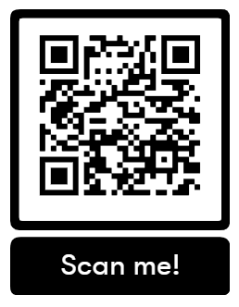
Group 1. Scan the QR code and answer the questions.
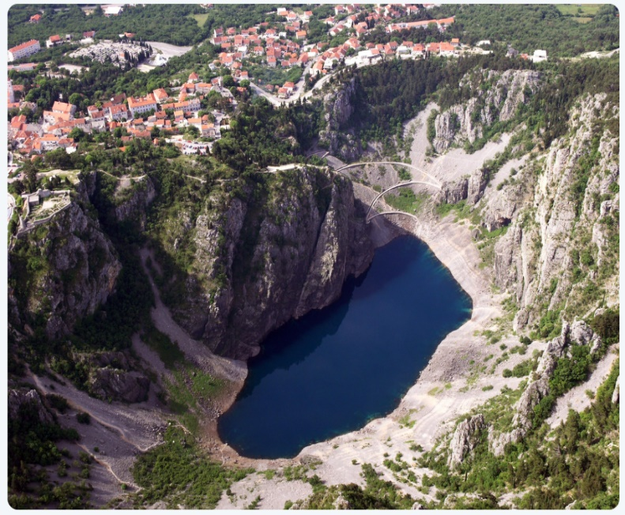
https://gp-biokovoimotski.com/

1. What does the UNESCO global Geopark Biokovo – Imotska Jezera mean for the local population?

_________________________________________________________________

_________________________________________________________________

2. List several activities that will connect the European Green Deal with the Blue Lake.

Group 2. Scan the QR code and answer the questions
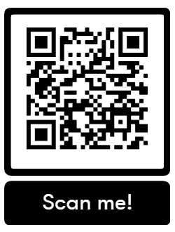
https://gp-biokovoimotski.com/

1.State which strategies you can apply in the Geopark Biokovo - Imotska jezera.

Annex 2.
Worksheet 2. Plants determination
Using the key or using the application Pl@ntNet https://plantnet.org/ or https://dihotomskikljuc.web.app/#
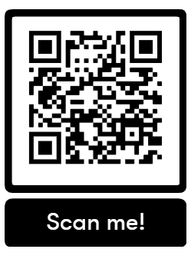

Type of tree: ___________________________

Annex 3.
Worksheet 3.: Calculating the height of the tree
Instructions :Calculating the height of the tree using a pencil and measuring tape is a simple task which relies on the basic principles of geometry and the similarity of triangles. Here are the steps how to do it :
Steps:
1. Find the flat surface and mark the spot:
- Stand on the flat surface and mark the place where you will stand .
- Move away from the tree at a certain distance ( e.g. 10 metres ). This will be your ”reference point”.
2. Hold the pencil vertically :
- Hold the pencil in your outstreched hand in front of you , so that the tip of the pencil is leveled with the top of the tree, and the pencil base is leveled with the tree base.
- You can adjust the distance from the eyes to the pencil to achieve this plane.
3. Slope and distance:
- Bend forward or backward to achieve that the pencil is leveled with the height of the tree.
- When you are sure that the pencil has exactly matched the tree , keep that position.
4. Distance measurement:
- Then measure the distance from your eyes to the pencil(we will mark this as d ).
- Also, measure the distance from your eyes to the tree base (this will be your "reference distance" D ).
5. Triangle similarity:
- We have two similar triangles: one small triangle formed by your eyes , pencil and hand , and another large triangle formed by your eyes, tree and ground.
- From the similarity of the triangles , the height of the tree H can be calculated using the formula:
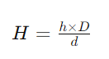
- h is the height of the pencil.
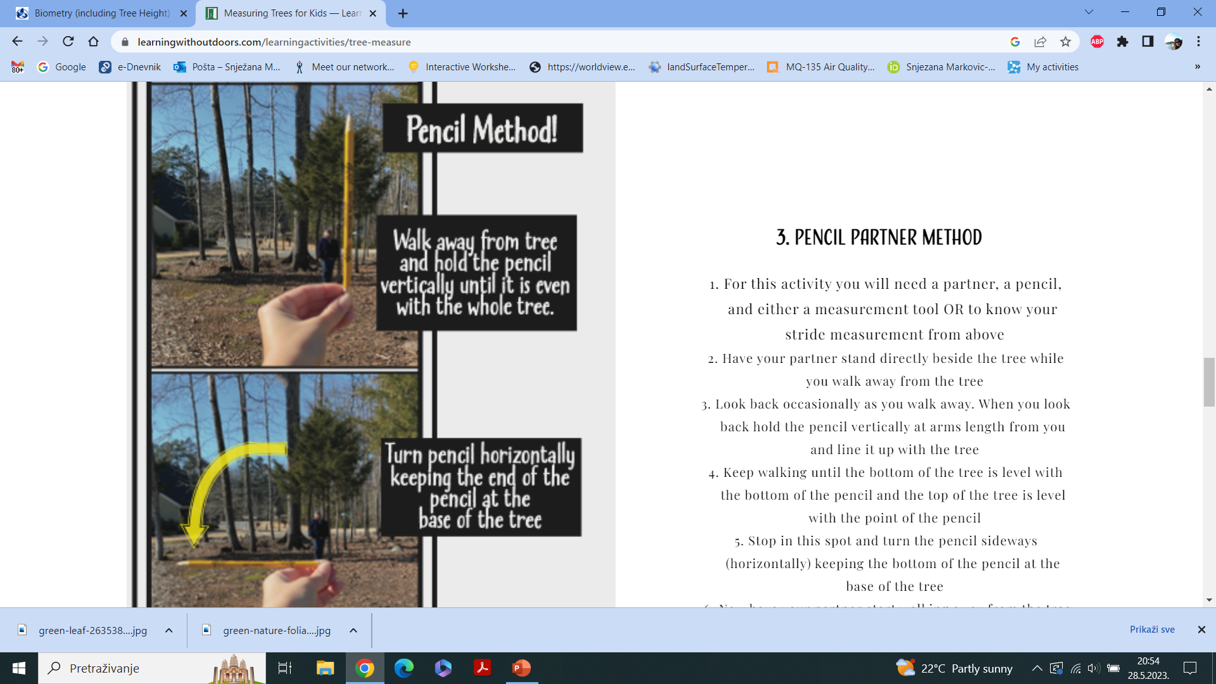
Example:
Suppose you measured the following:
- Height of the pencil h : 15 cm
- Distance from eyes to pencil d : 50 cm
- Distance from the eyes to the tree base D: 10 meters (1000 cm)

Then you calculate the height of the tree as follows:
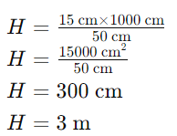
Conclusion-the height of the tree is 3 meters.
Advice :
- Be sure to hold the pencil vertically.
- Make sure you are on a flat surface.

Annex 4.
Worksheet 4.: Measuring the girth of a tree
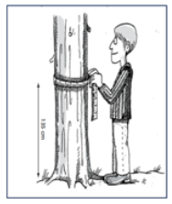
Tree scope: _______________

Tree age = girth / 2.5

Tree age = ____________

Annex 5.
Worksheet 5.: Estimating the carbon content of a tree
The assessment of the carbon content in a tree can be done using different methods, but the allometric approach is the most often used which is based on the measurement of tree dimensions and the application of specific formulas. Here are the steps to estimate the carbon content of the tree:
Steps:
1. Measure the diameter of the tree at breast height (DBH):
- DBH (engl. Diameter at Breast Height) is the diameter of the tree measured at a height of 1.3 meters from the ground. Use the tape measure for this measurement.
2. An example of a general formula for tree biomass is:
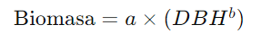
- Where a nad b are constants specific to the type of wood . These values can be found in scientific papers or forestry manuals , and you use chatGPT.
Ask chatGPT – in a question, give it a task:
Find the allometric formula for the type of wood( ENTER THE TYPE YOU DETERMINED) located in the forest around Blue Lake near Imotski .
5. Calculate the carbon content:
- Trees contain around 50% of their dry mass in the form of carbon. So, if the biomass of the tree is Biomass in kilograms , the carbon content is C:
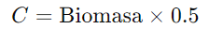
EXAMPLE FOR SOME TYPE OF TREE WHOSE DIAMETER (DBH) = 30
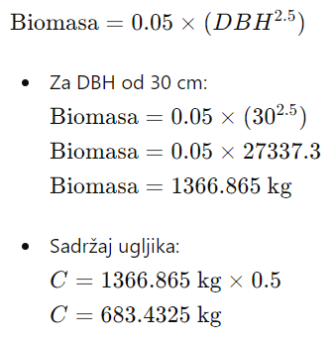
So, the estimated carbon content in the tree is approximately 683.43 kg.
Important Notes:
- Allometric formulas may vary for different tree species and regions. Use the most accurate formulaf or the type of tree you are measuring.
- Measurements should be as precise as possible in order for the assessment to be accurate.
- There are other methods such as direct sampling and laboratory analysis, but the allometric approach is the simplest for field assessment.
Table1.
Herbal type | height /m | Range/cm | Age = Girth / 2.5 | Biomass /kg | Carbon content

Annex 6.
Worksheet 6. Case study finder
Using the interactive map https://oppla.eu/case-study-finder find case studies from Croatia and fill in the table.
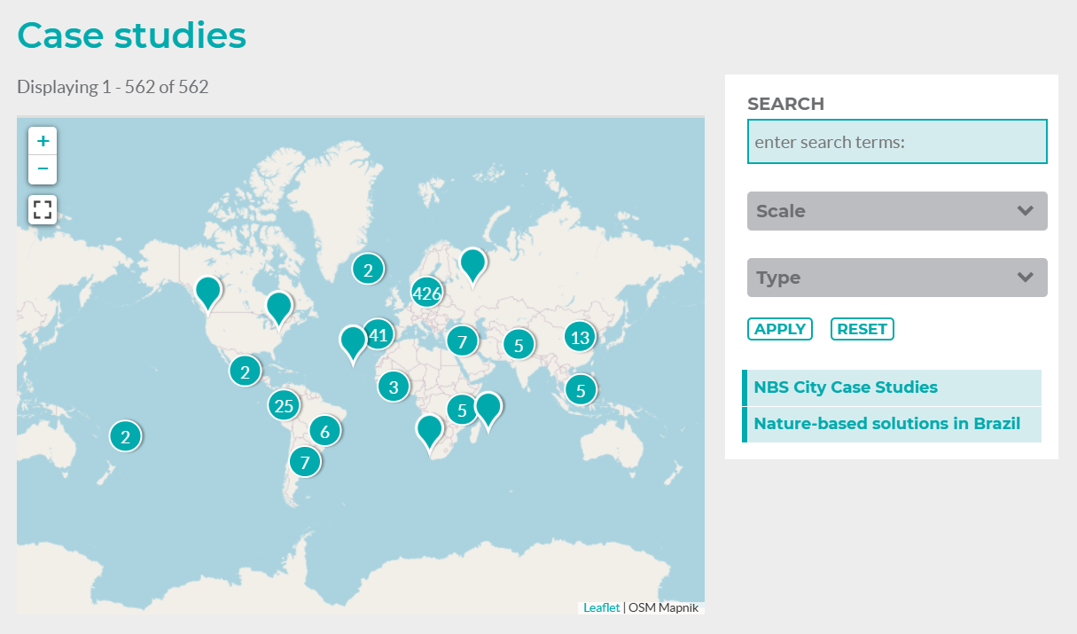
Case study | SDG

Annex 7.
Worksheet 7.- Assessment as Learning
Name and surname:_____________________________ Class:__________________
 | YES | NO | PARTIALLY
We completed our task successfully as a group.
Everyone in the group shared equally the work.
We made all decisions together during the work.
We respected the opinions of all members of the group.
I helped the group with my work.
How did you feel in group work?

How would you assess your contribution during group work?

